**Project Name:** NC County Statistics

**Project Team:** Niral Patel, Eunjeong Lee, Bill Pezzullo, Abby Pearson, Teshanee

**Project** **Description:**

NC county Census data analysis for multiple years. This dashboard will provide visibly into the population and number of employed people for period of years. User will have option to drill down into the data per county in NC to learn more about each county.

**Project Rational:**

NC Census data provides valuable insight into growth and demographic changes overtime. We will develop consolidated dashboard using various tools and technique. Since we will be looking into historical data compared to new data structure this provide unique opportunity to develop dashboard with various data structures.

**Screenshot of the metadata:**

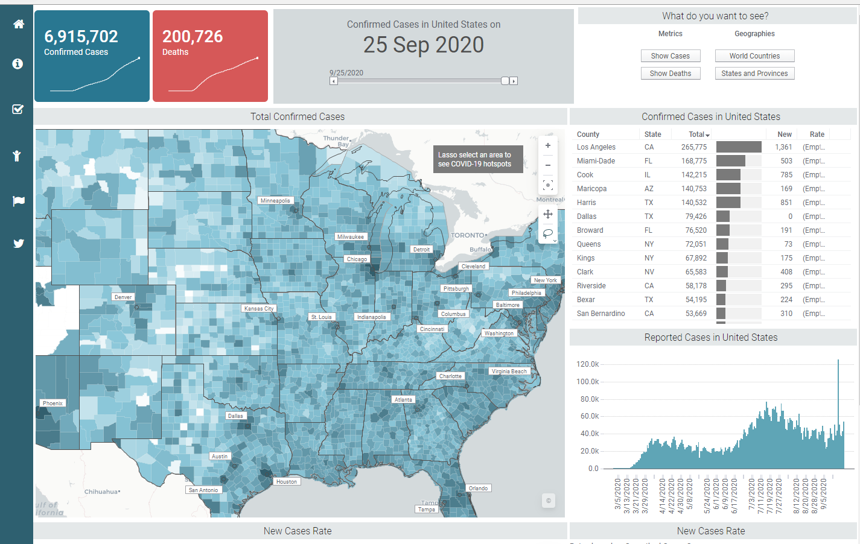

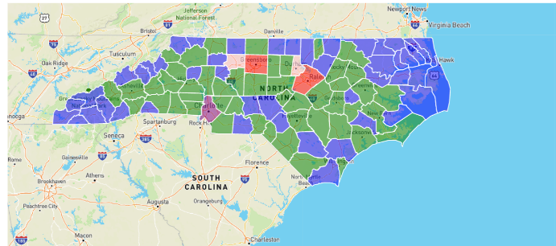

**Link to dataset:**

[Census](https://api.census.gov/)

[Community Business Pattern(CBP)](https://www.census.gov/programs-surveys/cbp.html)

[CBP API](https://www.census.gov/data/developers/data-sets/cbp-nonemp-zbp/cbp-api.html)

**[https://api.census.gov/data/1986/cbp?get=GEO_TTL,SIC_TTL,EMP,ESTAB&for=county:*&in=state:37](https://api.census.gov/data/1986/cbp?get=GEO_TTL,SIC_TTL,EMP,ESTAB&for=county:*&in=state:37)**

[**https://api.census.gov/data/2018/cbp?get=NAICS2017_LABEL,NAICS2017,GEO_ID,LFO,LFO_LABEL,EMPSZES_LABEL,EMPSZES,EMP&for=county:*&in=state:37**](https://api.census.gov/data/2018/cbp?get=NAICS2017_LABEL,NAICS2017,GEO_ID,LFO,LFO_LABEL,EMPSZES_LABEL,EMPSZES,EMP&for=county:*&in=state:37)

<https://ncosbm.opendatasoft.com/pages/nc-complete-count-committee/?refine.area_name=Alamance%20County>

**A sketch of final design:**

NC County Map with fill color with employment number

* Fill color will be total people employed respective year
* County clicked on
  + Total population
  + Employment ratio

Top Banner:

Total number of counties, Total Population count respective year, (moveable bar that goes by year)

Side Manu,

Home button

Various analysis

Horizontal bar chart of employees by business type

* When no county selected on the map it shows state level data
* When county selected on the map it shows county level data

(Open for discussion)

Potential:

* Jobs data
* Population data
* Unemployment data
* Time chart for the county from 1986 to 2018

**Link to GitHub:**

https://github.com/ejlee127/NC-County-Statistics

High Level file and data flow:

Logic.js

App.py

(route/index)

Index.html

CSS

MongoDB

JupiterNote.py

App.py  
(route/online)

Online Sources

(Fill in later)  
data labels to call out in code to pull.

NC Count Map will be stored in MongoDB

County ID  
(Key)

Link to Geo Json data

Link to Census Data

App.py  
(route/online)

Documents:  
- North American Industry per year

Documents:  
- County Population per year

Documents:  
- County Codes to name  
 County Name,  
 Count ID

Document:  
- NC map data  
 County Name,  
 Lat & Lon

Documents:  
- Employment per year   
 County,  
 Employment#

MongoDB  
(Census Data Base)